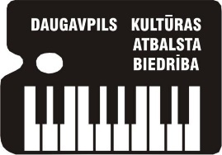
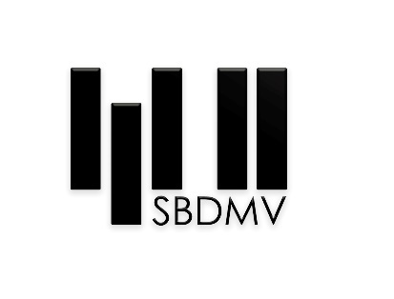

X International Chamber Ensembles Competition
NOVA MUSICA
REGULATIONS

The Society of Cultural Support of Daugavpils and Stanislavs Broks Daugavpils Music Secondary school in collaboration with Daugavpils City Council, with the support of the Culture Capital Foundation of Latvia, organize the X International Chamber Ensembles Competition NOVA MUSICA.

The aims and goals of the competition
- To popularize chamber music composed during the period of the last 100 years;
- To promote the performance of chamber instrumental music composed by Latvian composers;
- To encourage and promote creative activity of young composers in the sphere of chamber ensembles, piano duets and Latvian folk music finishing;
- To focus teachers and students’ attention on the variety of trends and styles in works of music of XX and XXI centuries;
- To diversify pedagogical and concert repertoire;
- To discover and support the most talented music performers;
- To establish contacts between students and teachers, as well as between educational establishments in West and East.

Time and place
The competition will be held on 30th November (rehersals) and 1st December (performances), 2023, in Staņislavs Broks Daugavpils Music Secondary School.
The address: Kandavas iela 2A, Daugavpils, LV-5401, Latvia, phone (+371) 5407900, email sbdmv@sbdmv.lv

Participants
Piano ensembles, acoustic insrument chamber ensembles with or without the piano (from 3 up to 9 members) (4, 6, 8 hands) can take part in the competition. The number of participants 2 (4- handed), 3(6- handed), 4 (8 – handed) pianists in the ensemble; 3-9 participants in other ensembles (with or without the piano) During the performance the players’ complement cannot be changed.

The contest will be held in four age groups:
A up to 10 years of age (including)
B up to 13 years of age (including)
C up to 16 years of age (including)
D up to 20 years of age (including)

Programme
The competition has one round. Each ensemble has to play two pieces, composed within the period of 1923 – 2023 (included):

1. A composition, a cycle, or its part (parts) composed by a composer from the participant’s represented country;
2. A composition, a cycle, or its part (parts), composed by a composer other than from the participant’s represented country;

Only original works must be included in the programme of piano duos. As for other chamber ensembles, as well as piano ensembles for 6 and 8 hands, it is allowed to use adapted pieces; in this case the author of the adaption should be mentioned. When arriving to the competition the sheetmusic has to be handed in to the managing committee.
The program submitted in the application cannot be changed.
Participants are allowed to use their notes during the performance.

Programme timing (total time on stage ):
Group A 4-7 min
Group B 6-9 min
Group C 8-11 min
Group D 10-14 min
The order of performances are set by lottery.

Assessment
The contest will be assessed by an international jury. The members of the jury will not evaluate own students. The participants will be marked after a 25-point system. The decision of the jury is final and is not to be reconsidered.

Awarding
The winners of the contest will be given diplomas of degrees I, II, III, and prizes.
In addition, the following prizes will be awarded:
- For the best performance of a foreign composer’s work;
- For the best performance of a national composer’s work;
Special awards and premiums can be given by juridical and physical persons, as well as by public organizations.
The competition is open. The laureates of the contest perform in the final concert free of charge. The managing committee has the right to broadcast the contest on the radio, on television, to do audio and video records, to distribute the records in non-commercial aims without paying fees.

Application
The participants should send in the following documents:
- application form (the form is enclosed);
- a photo of the ensemble (good quality of JPG format);
- a copy of a document on payment to the bank account.
The application form should be sent in to an email sbdmv@sbdmv.lv by November 10, 2023.

Participation fee is 20 euros; It must be transferred to the following account by November 10, 2023:
Stanislavs Broks Daugavpils Mūzikas vidusskola, Kandavas iela 2A, Daugavpils, LV- 5401, Latvija,
Reg.Nr.90000066001
Current account LV04TREL2220521005000
VALSTS KASE, bank code TRELLV22
Kameransambļu konkursam.

The participation fee can be paid when arriving to the competition as well.
Travel and accommodation expanses are covered by the participants.

Application form

Ensemble’s name | Names, surnames of the participants of ensemble’s members, instruments | Dates of birth | Age group | Country, town, school, school address, telephone number, email | Teacher’s name, surname, telephone number, email | Programme | Total Timing

